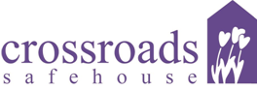

**2011 Auction Item Donation Form**

**Auction will be held during the**

**Crossroads Safehouse 31st Anniversary Gala**

**November 5, 2011 at the Hilton Fort Collins**

### Donor Information

|  |  |
| --- | --- |
| Name |  |
| Company Name |  |
| Address |  |
| City |  |
| State |  |
| ZIP Code |  |
| Telephone |  |
| Fax |  |
| E-Mail |  |

### Pledge Information

|  |  |  |  |
| --- | --- | --- | --- |
| Type of Donation | ___ Gift Certificate ___ Merchandise ___ Monetary ___ Other | | |
| Value of Donation | $ | Minimum Bid | $ |
| Description of Donation  (Please be specific i.e. brand, size, color, etc.) |  | | |
| Please Check One:  🗆 I will provide printed materials for display at the auction  🗆 I authorize Crossroads Safehouse to create printed materials for display | | | |
| Special Display Instructions: | | | |

### Acknowledgement Information

Please use the following name(s) in all acknowledgements:

|  |
| --- |
|  |
| Authorized Signature(s) |
| Date |

**CROSSROADS SAFEHOUSE IS A § 501(C)3 NONPROFIT ORGANIZATION UNDER OF THE INTERNAL REVENUE CODE. YOUR DONATION IS A FULLY TAX-DEDUCTIBLE CHARITABLE CONTRIBUTION AND MAY ALSO QUALIFY FOR AN ADDITIONAL STATE ENTERPRISE ZONE TAX CREDIT.**

**For Crossroads office use only:**

***Solicitor Name:_______________________________________________________________***

***Phone Number:_______________________________________________________________***

2010 United Way Spirit of Giving Award

2009 Fort Collins Housing Authority Soul of the City Award

2008 Colorado Coalition Against Domestic Violence Exemplary Organization Award

2007 *The Coloradoan* Best in Business Award Winner

2006 Affordable Housing of Larimer County Agency Recognition Award

2005 Fort Collins Human Relations Commission Award

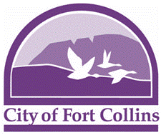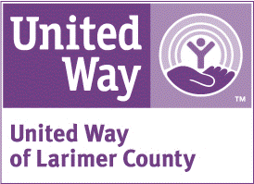

**P.O. Box 993 · Fort Collins, CO 80522 · Business Line: 970-530-2353 · Crisis Line: 970-482-3502**

**Toll-free Hotline: 1-888-541-SAFE (7233) · www.crossroadssafehouse.org**